USE CompanyDB;
GO
CREATE OR ALTER PROCEDURE sp_GetEmployeesByDepartment
@DepartmentID INT
AS
BEGIN
SELECT *
FROM Employees
WHERE DepartmentID = @DepartmentID;
END;
GO
EXEC sp_GetEmployeesByDepartment @DepartmentID = 1;
GO

CREATE OR ALTER PROCEDURE sp_InsertEmployee
@FirstName VARCHAR(50),
@LastName VARCHAR(50),
@DepartmentID INT,
@Salary DECIMAL(10,2),
@JoinDate DATE
AS
BEGIN
INSERT INTO Employees
(FirstName, LastName, DepartmentID, Salary, JoinDate)
VALUES
(@FirstName, @LastName, @DepartmentID, @Salary, @JoinDate);
END;
GO
EXEC sp_InsertEmployee
@FirstName = 'Sophia',
@LastName = 'Taylor',
@DepartmentID = 3,
@Salary = 72000.00,
@JoinDate = '2024-06-15';
GO
SELECT * FROM Employees;
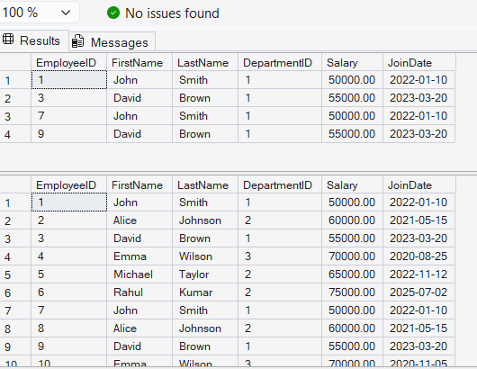
GO

